BAR

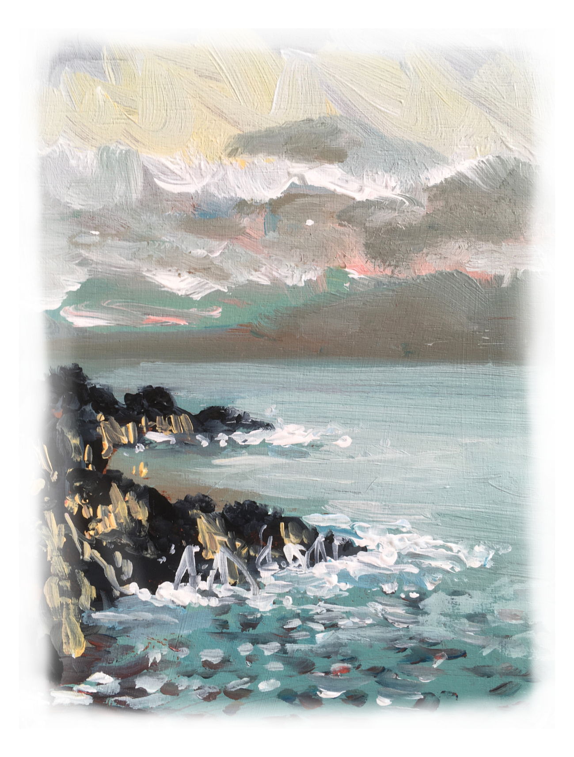
Aperitifs
Martini Bianco | 4.50€
Martini Rosso | 4.50€
Moscatel | 4.50€

Still Drinks
 | Bottle:
Water 37.5cl | 2.00€
Water 1l | 3.50€
Fuze Tea | 2.20€
 | Glass:
Natural Orange Juice | 4.00€
Compal  (Pineapple, Orange, Apple and Passion Fruit) | 2.00€

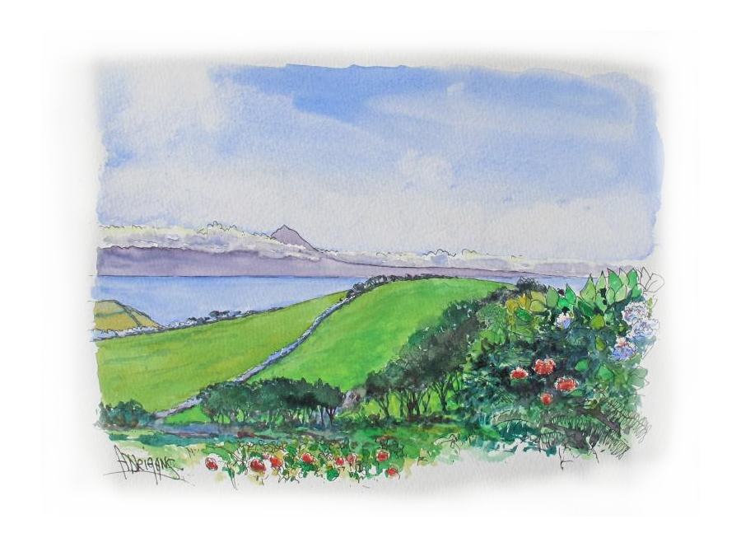
Sparkling Drinks
Sparkling water 25cl | 2.00€
Sparkling water 75cl | 3.50€
Sparkling water with flavour | 2.00€
Tonic (Fever tree) | 3.00€
Coca-Cola | 2.30€
Coca-Cola Zero | 2.30€
Fanta | 2.30€
Sprite | 2.30€
Kima (Passion fruit or Pineapple) | 2.50€

Hot drinks
Coffee (espresso) | 1.00€
American Coffee (big diluted espresso) | 1.60€
Dripping coffee (espresso with a drop of milk) | 1.00€
Cappuccino | 2.00€
Carioca (diluted expresso) | 0.80€
Carioca with lemon zest | 0.80€
Tea | 1.50€
Decaf coffee | 1.00€
Galão (big coffee with milk) | 2.00€
Garoto (espresso with half milk) | 1.00€
Meia de Leite (coffee with milk) | 1.50€

Beer & Cider
Super Bock 33cl | 2.20€
Super Bock Black 33cl | 2.20€
Super Bock Abadia 33cl | 2.20€
Super Bock Zero 33cl | 2.20€
Super Bock Zero Black 33cl | 2.20€
Super Bock Japenese Lager 33cl | 4.50€
Super Bock Weiss 33cl | 4.50€
Super Bock Dunkel 33cl | 4.50€
Coruja IPA 33cl | 3.00€
Apple Cider 50cl | 3.50€
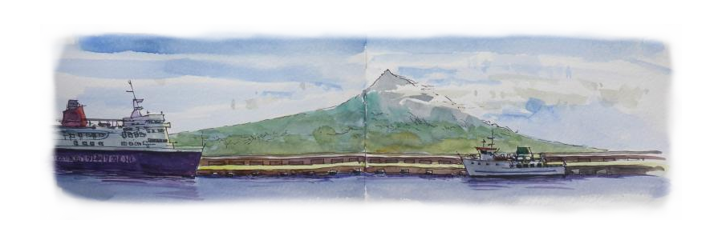

Imported beer
 | Glass:
Heineken 25cl | 2.00€
Heineken 50cl | 3.50€
Panachê | 2.00€
 | Bottle:
Budweiser 5% | 4.00€
Bush Caractere 12%
Chimay Bleue 9% | 6.00€
Corona 4.5% | 3.50€
Franziskaner Weiss 5% | 4.50€
Franziskaner Dunkel 5% | 4.50€
Heineken Zero | 2.00€
La Chouffe 8% | 6.00€
Leffe Blond 6.6% | 4.00€
Leffe Brune 6.6% | 4.00€
Stella Artois 5% | 3.50€


Cocktails
Aperol Spritz  (Prosecco, Aperol and sparkling water) | 6.00€
Blue Lagoon  (Vodka, Blue Curaçao, lemon juice and Sprite) | 8.00€
Brumble  (Gin, lemon juice, brown sugar, blackberry liquor) | 8.00€
Caipilão  (Melon Vodka, lime, brown sugar) | 8.00€
Caipirinha  (Cachaça, lime juice, brown sugar and limes) | 8.00€
Caipiroska  (Vodka, lime juice, brown sugar and limes) | 8.00€
Caipiágua  (water, brown sugar and limes) | 5.00€
Cuba Libre  (Rum, Coca Cola and lemon juice) | 8.00€
Daiquiri  (Rum, *fruit juice and sugar) | 8.00€
Dry Martini  (Gin and Martini Bianco) | 8.00€
Expresso Martini  (Vodka, Kahlua, coffee and sugar) | 9.00€
Irish Coffee  (Jameson, Coffee, sugar and whipped cream) | 7.50€
Jack & Coke  (Jack Daniels and Coca Cola) | 8.00€
Lemon Drop  (Vodka, Triple Sec, lemon juice and sugar) | 8.00€
Long Island Iced Tea  (Vodka, Rum, Tequila, Gin, Triple Sec, lemon juice, Coca Cola and brown sugar) | 12.00€
Maracujinha  (Vodka, passion fruit lquor, passion fruit juice) | 8.00€
Margarita  (Tequila, *fruit juice and sugar) | 8.00€
Mojito  (Rum, lime juice, sugar, sparkling w. and mint) | 9.00€
Moscow Mule  (Vodka, Ginger Beer and lime juice) | 9.00€
Negroni  (Gin, Bitter Campari and Martini Rosso) | 8.00€
Pina Colada  (Rum, coconut liqueur and pine apple juice) | 9.00€
Sour  (Whisk(e)y, vodka or rum, lemon juice and sugar) | 8.00€
Tequila Sunrise  (Tequila, Orange juice and Redcurrant syrup) | 8.00€
White Lady  (Gin, Triple Sec, lemon juice and sugar) | 8.00€

* Juice: Orange, Lime, Pineapple, and Passion Fruit
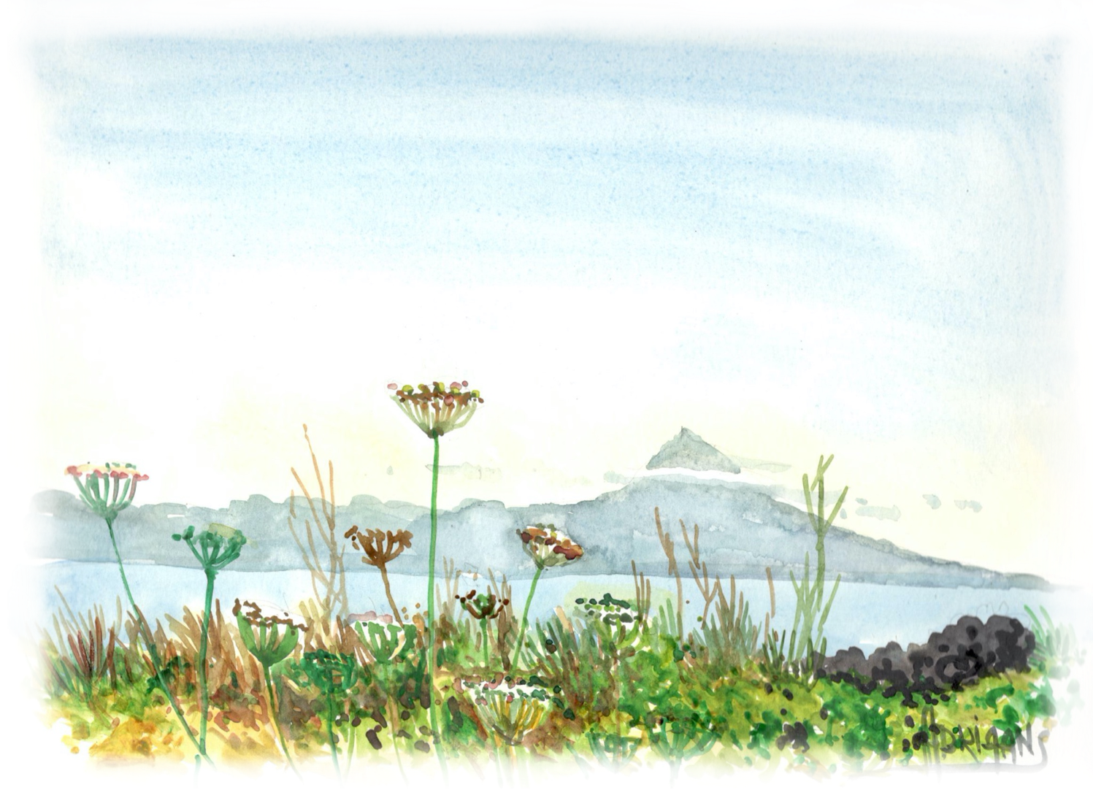
Gin
Adamus | 13.00€
Black Pig | 13.00€
Black Pig Montado | 15.00€
Bombay Sapphire | 11.00€
Bulldog | 13.00€
Etsu | 14.00€
Etsu Reserva | 16.00€
Gordon’s | 9.00€
Gordon’s Pink | 9.00€
Hendrick’s | 13.00€
Hendrick’s Grand Cabaret | 14.00€
Hendrick’s Flora Adora | 14.00€
Hendrick’s Lunar | 14.00€
Hendrick’s Midsummer Solstice | 14.00€
Hendrick’s Neptunia | 14.00€
Hendrick’s Oasium | 14.00€
Hendrick’s Orbium | 14.00€
Martin Miller’s | 12.00€
Mombasa | 18.00€
Monkey 47 | 19.00€
Nikka | 17.00€
Nº 3 | 10.00€
Nordés | 9.00€
Opihr | 9.00€
Sharish | 11.00€
Sharish Blue | 11.00€
Tanqueray | 11.00€
Tanqueray Ten | 13.00€
 | Gin from the Azores:
Azor Dry | 15.00€
Azor Premium | 16.00€
Azor Reserva | 18.00€
Azor Zero | 11.00€
Rabo Peixe | 15.00€
Rocha Negra | 15.00€

Whisk(e)ys | ½ Dose | Dose
Bushmills | 4.50€ | 9.00€
Bushmills Black Bush (Sherry Cast) | 6.00€ | 12.00€
Bushmills Single Malt 10 Years |  | 14.00€
Glenfiddich 10 Years |  | 12.00€
Jack Daniel’s | 5.00€ | 10.00€
Jack Daniel’s Gentleman Jack |  | 16.00€
Jack Daniel’s Fire | 4.50€ | 9.00€
Jack Daniel’s Honey | 4.50€ | 9.00€
Jack Daniel’s Maçã | 4.50€ | 9.00€
Jack Daniel’s Single Barrel |  | 16.00€
Jameson | 4.50€ | 9.00€
Jameson Black Barrel |  | 11.00€
J. Walker Red Label | 4.50€ | 9.00€
J. Walker Black Label | 5.00€ | 10.00€
J. Walker Double Black |  | 12.00€
J. Walker Gold Label Reserva |  | 14.00€
Monkey Shoulders |  | 11.00€
Nikka the Barrel |  | 17.00€
Nikka Taketsuru |  | 20.00€

Tequila
Tres Sombreros | 4.50€
Patron Silver | 7.50€
Patron Repousado | 9.50€
Patron Añejo | 10.50€

Vodka
Smirnoff | 5.00€
Absolut | 6.50€
Belvedere Pink Grapefruit | 8.00€
Ciroc Pineapple | 8.00€
Ciroc Peach | 8.00€
Ciroc Apple | 8.00€
Ciroc Mango | 8.00€
Grey Goose | 9.00€
Grey Goose Cherry | 9.00€
Grey Goose Pear | 9.00€

Aguardentes, Cognac & Rum | ½ Dose | Dose
Aguardente Aged | - | 6.00€
Aguardente S. Bartolomeu Pear | 5.00€ | 10.00€
Aguardente Morello Cherry | 4.00€ | 8.00€
Antiqua Aguardente Old | - | 6.00€
Barceló Añejo | - | 8.00€
Brandy Croft | - | 5.00€
CRF | - | 6.00€
CRF Reserva Extra | - | 9.00€
Courvoisier Cognac | 4.50€ | 9.00€
Diplomático Exclusive Reserve | - | 10.00€
Hine Cognac | 5.00€ | 10.00€
 | Aguardentes from Azores:
Bagaceira (Grape Marc Brandy) |  | 3.00€
Fig |  | 4.50€
Loquat |  | 4.50€
Pineapple |  | 4.50€

Liqueurs & Others
Amarula |  | 5.00€
Bitter Almond |  | 4.50€
Beirão |  | 4.50€
Drambuie |  | 6.50€
Grand Marnier |  | 7.00€
Jagermeister |  | 4.50€
Macieira Cream |  | 4.50€
Macieira Cream Salted Caramel |  | 4.50€
Red Port Wine |  | 4.50€
White Port Wine |  | 4.50€
Port wine Dona Antonia (Reserva) |  | 6.50€
Kahlua |  | 5.00€
 |  | Liqueurs from Azores:
Blackberry |  | 4.50€
Angelica |  | 5.00€
Lajido (Liqueur) |  | 6.50€
Neveda (Calemint) |  | 4.50€
Honey |  | 4.50€
Tangerine |  | 4.50€
